📌 Module 2

🔄 The Square of Opposition

🗣️ Core Terminology & Standard Categorical Templates
Logical Opposition – The formal relationship existing between categorical propositions that share the exact same subject ($S$) and predicate ($P$) terms, yet differ in quantity (Universal vs. Particular), quality (Affirmative vs. Negative), or both.
⤷ Intuition: Taking the exact same two nouns and changing the "how many" (All/Some) or the "yes/no" (are/are not) to see how the truth of one statement forces the truth, falsity, or uncertainty of another.
The Four Standard-Form Categorical Propositions ($A,E,I,O$):
🔹 $A$ Proposition (Universal Affirmative):
"All $S$ are $P$." (Quantity: Universal | Quality: Affirmative $+$)
🔹 $E$ Proposition (Universal Negative):
"No $S$ are $P$" or "All $S$ are not $P$." (Quantity: Universal | Quality: Negative $-$)
🔹 $I$ Proposition (Particular Affirmative):
"Some $S$ are $P$." (Quantity: Particular | Quality: Affirmative $+$)
🔹 $O$ Proposition (Particular Negative):
"Some $S$ are not $P$" or "Not all $S$ are $P$." (Quantity: Particular | Quality: Negative $-$)
⤷ Note on Uniformity: Standard quantifiers are restricted to these templates unless the subject is singular, though "none" may be used in appropriate cases for $E$ propositions.

📐 Visual Architecture of the Square
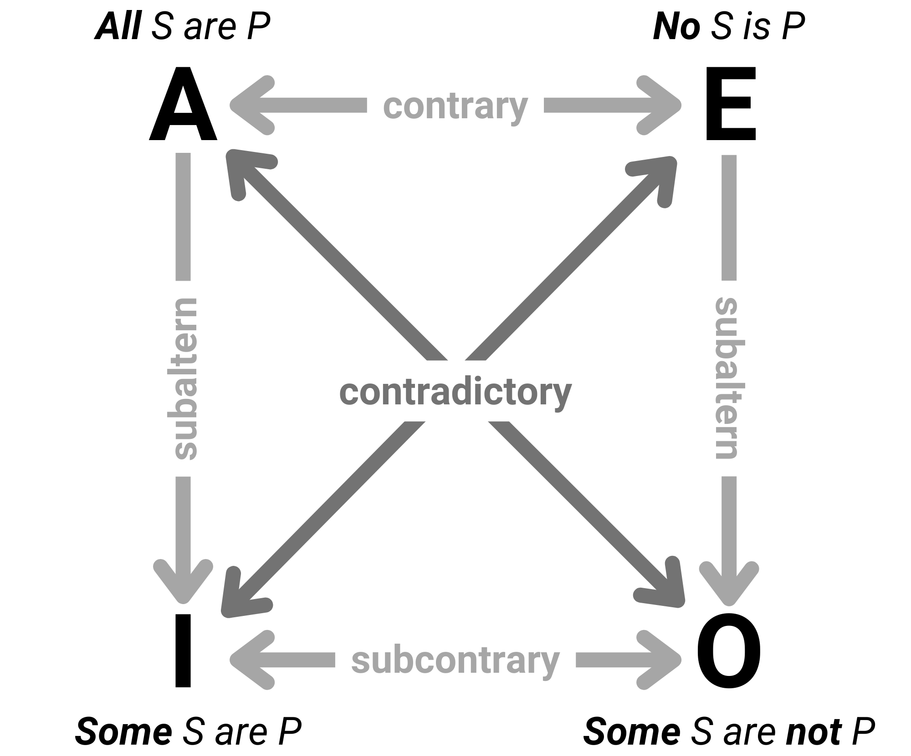

⚖️ The Four Types of Logical Opposition

Contradictory ($CD$): $A↔O$ and $E↔I$
- Formal Definition: The relation between two propositions that differ in both quantity and quality (located diagonally across the square).
- In logic gates, this is equal to XOR (exclusive or, meaning if one is true the other must be false)
🔑 Key Intuition: "Always Opposite (TF / FT)"
⤷ Because one makes a 100% claim ("All") and the other only needs a single exception ("Some are not"), there is zero middle ground. They can never both be true, and they can never both be false. Flipping one guarantees the exact opposite truth value for the other.

- Truth Value Rules:
⤷ If 1st is TRUE $→$ 2nd is FALSE
⤷ If 1st is FALSE $→$ 2nd is TRUE

- 🧪 Exhaustive Cases & Examples:
→ Case 1 ($A$ is True $→O$ is False):
Given $A$: "All are happy" (TRUE) $⟹$ Contradictory $O$: "Some are not happy" is FALSE.
→ Case 2 ($I$ is False $→E$ is True):
Given $I$: "Some animals are ugly" (FALSE) $⟹$ Contradictory $E$: "All animals are not ugly" is TRUE.
→ Case 3 ($O$ is True $→A$ is False):
Given $O$: "Not all animals are aquatic" (TRUE) $⟹$ Contradictory $A$: "All animals are aquatic" is FALSE.
→ Case 4 ($E$ is False $→I$ is True):
Given $E$: "All smokers are not healthy" (FALSE) $⟹$ Contradictory $I$: "Some smokers are healthy" is TRUE.

Contrary ($CT$): $A↔E$
- Formal Definition: The relation between two Universal propositions that differ purely in quality ($+$ vs. $-$, located across the top of the square).
- In logic gates, this is equivalent to NAND (not and, meaning any pair that isn’t both true yields true)
🔑 Key Intuition: "Cannot Both Be True / But both can be False (TF / FD)"
⤷ Two 100% extremes ("All are" vs. "None are") cannot both be right at the same time. However, both can be wrong if the truth lies in the middle ("Some are, some aren't"). Therefore, knowing one extreme is False leaves the other extreme Doubtful (undetermined) because you don't know if the reality is the opposite extreme or just a partial middle ground.

- Truth Value Rules:
⤷ If 1st is TRUE $→$ 2nd is FALSE
⤷ If 1st is FALSE $→$ 2nd is DOUBTFUL ($D$)

- 🧪 Exhaustive Cases & Examples:
→ Case 1 ($A$ is True $→E$ is False):
Given $A$: "All soaps are cleansers" (TRUE) $⟹$ Contrary $E$: "All soaps are not cleansers" is FALSE. (Also: "All diamonds are gems" [T] $→$ "All diamonds are not gems" [F]).
→ Case 2 ($E$ is True $→A$ is False):
Given $E$: "No Bikolanos are Filipinos" (TRUE) $⟹$ Contrary $A$: "All Bikolanos are Filipinos" is FALSE.
→ Case 3 ($E$ is False $→A$ is Doubtful):
Given $E$: "No women are married" (FALSE) $⟹$ Contrary $A$: "All women are married" is DOUBTFUL (Why? Because the actual truth is the particular statement: "Some women are married"). (Also: "No apples are mangoes" [F] $→$ "All apples are mangoes" [D]).
→ Case 4 ($A$ is False $→E$ is Doubtful):
Given $A$: "All flowers are roses" (FALSE) $⟹$ Contrary $E$: "All flowers are not roses" is DOUBTFUL.

Subcontrary ($SCT$): $I↔O$
- Formal Definition: The relation between two Particular propositions that differ purely in quality ($+$ vs. $-$, located across the bottom of the square).
- In logic gates, this is equivalent to OR (atleast one has to be true in order for the truth value to be true)
🔑 Key Intuition: "Cannot Both Be False / Partial Overlap (FT / TD)"
⤷ Intuition: The exact mirror image of Contraries. Two partial claims ("Some are" and "Some are not") can easily both be true at the same time (e.g., some students pass, some fail). Thus, knowing one is True leaves the other Doubtful. However, if a small claim like "Some are" is completely False (meaning none are), then "Some are not" is forced to be True.
- Truth Value Rules:
⤷ If 1st is FALSE $→$ 2nd is TRUE
⤷ If 1st is TRUE $→$ 2nd is DOUBTFUL ($D$)

- 🧪 Exhaustive Cases & Examples:
→ Case 1 ($I$ is False $→O$ is True):
Given $I$: "Some women are married" (FALSE) $⟹$ Subcontrary $O$: "Some women are not married" is TRUE. (Also: "Some triangles are squares" [F] $→$ "Some triangles are not squares" [T]).
→ Case 2 ($O$ is False $→I$ is True):
Given $O$: "Some students are not present" (FALSE) $⟹$ Subcontrary $I$: "Some students are present" is TRUE.
→ Case 3 ($I$ is True $→O$ is Doubtful):
Given $I$: "Some soaps are cleansers" (TRUE) $⟹$ Subcontrary $O$: "Not all soaps are cleansers" is DOUBTFUL (Why? Because it is possible that All soaps are cleansers). (Also: "Some basketball players are tall" [T] $→$ "Some basketball players are not tall" [D]).
→ Case 4 ($O$ is True $→I$ is Doubtful):
Given $O$: "Some scholars are not dumb" (TRUE) $⟹$ Subcontrary $I$: "Some scholars are dumb" is DOUBTFUL.

Subalternation ($SA$): $A↕I$ and $E↕O$
- Formal Definition: The vertical relation between a Universal proposition (Superaltern: $A$ or $E$) and its corresponding Particular proposition (Subaltern: $I$ or $O$) sharing the exact same quality ($+$ or $-$) but differing in quantity ($U$ vs. $P$).
- In propositional math, this is almost equivalent to a Conditional (if then statement)
🔑 Key Intuition Phrase: "Truth Flows Down, Falsity Flows Up (UTT / PFF)"
⤷ Intuition (Water & Poison Analogy):
    - Truth Flows Down ($U=\text{True}→P=\text{True}$):
If something is true for the entire group ($U$), it automatically cascades down as true for some part of that group ($P$). Conversely, if it is only true for some ($P=\text{True}$), you cannot guarantee it applies to all ($U=\text{Doubtful}$).
    - Falsity Flows Up ($P=\text{False}→U=\text{False}$):
If a claim fails for even a single/partial instance ($P=\text{False}$, meaning not even one fits), then the universal claim ($U$) is completely dead (False). Conversely, if the "All" claim is false ($U=\text{False}$), it might still be true for a few ($P=\text{Doubtful}$).

- Truth Value Rules:
⤷ If Universal ($U$) is TRUE $→$ Particular ($P$) is TRUE
⤷ If Universal ($U$) is FALSE $→$ Particular ($P$) is DOUBTFUL ($D$)
⤷ If Particular ($P$) is TRUE $→$ Universal ($U$) is DOUBTFUL ($D$)
⤷ If Particular ($P$) is FALSE $→$ Universal ($U$) is FALSE
- 🧪 Exhaustive Cases & Examples:
→ Case 1 ($U$ is True $→P$ is True):
Given $A$: "All of those who came enjoyed" (TRUE) $⟹$ Subaltern $I$: "Some of those who came enjoyed" is TRUE.
→ Case 2 ($U$ is False $→P$ is Doubtful):
Given $A$: "All women are married" (FALSE) $⟹$ Subaltern $I$: "Some women are married" is DOUBTFUL. (Also: Given $E$: "All smokers are not healthy" [F] $→$ Subaltern $O$: "Some smokers are not healthy" [D]).
→ Case 3 ($P$ is True $→U$ is Doubtful):
Given $I$: "Some soaps are cleansers" (TRUE) $⟹$ Superaltern $A$: "All soaps are cleansers" is DOUBTFUL (Possible: Some soaps are not cleansers). (Also: "Some oranges are sweet" [T] $→$ "All oranges are sweet" [D]).
→ Case 4 ($P$ is False $→U$ is False):
Given $O$: "Some men are not spiritual" (FALSE) $⟹$ Superaltern $E$: "No men are spiritual" is FALSE (and by extension, $A$: "All devils are good" is TRUE when $O$: "Some devils are not good" is FALSE).

📊 Master Cheat-Sheet: Square of Opposition Truth Matrix
Relationship | Code | Pairings | 1st is TRUE (TTT) | 1st is FALSE (FFF) | Mnemonic Rule
Contradictory | CD | $A↔O$,  $E↔I$ | FALSE ($F$) | TRUE ($T$) | TF / FT (Always Opposite)
Contrary | CT | $$A↔E$$ | FALSE ($F$) | DOUBTFUL ($D$) | TF / FD (Cannot both be $T$)
Subcontrary | SCT | $$I↔O$$ | DOUBTFUL ($D$) | TRUE ($T$) | FT / TD (Cannot both be $F$)
Subaltern (Down) | SA | $A→I$,  $E→O$ | TRUE ($T$) | DOUBTFUL ($D$) | UTT (Universal $T→$ Part. $T$)
Subaltern (Up) | SA | $I→A$,  $$O→E$$ | DOUBTFUL ($D$) | FALSE ($F$) | PFF (Particular $F→$ Univ. $F$)

🏛️ Categorical Syllogisms

🧱 Foundations: Arguments, Reasoning, Validity, & Soundness
⤷ Argument – An instance of reasoning containing a minimum of two (2) statements—at least one Premise and one Conclusion—where the premise(s) claim to provide evidence for the truth of the conclusion.

Fundamental Types of Arguments:
  - Deductive Argument: Moves from a universal proposition to a particular proposition (General $→$ Specific/Particular).
  - Inductive Argument: Moves from a particular instance to a universal proposition (Specific/Particular $→$ General).
⤷ Categorical Syllogism – A three-line deductive argument consisting of exactly 2 premises and 1 conclusion, composed strictly of standard-form categorical propositions that represent a connected chain of thought.

Content vs. Form (Validity vs. Soundness):
  - Content → The actual real-world subject matter or factual truth of the statements.
  - Form → The structural pattern or logical architecture of the argument.
🔹 Validity: Concerns ONLY the form, never the content. It analyzes whether the structure forces the conclusion. (Note: Only deductive arguments can be classified as valid or invalid).
🔹 Soundness: Concerns BOTH content and form. A deductive argument is Sound if and only if it is structurally Valid AND contains only factually true premises.
⤷ Intuition: Validity is a well-built baking pan (structure); Truth is good batter (content). Soundness is a perfect cake—it requires both the right pan and real ingredients.

🔍 Step-by-Step Anatomy (Finding Premises, Conclusion, & Terms)

🔹 Step 1: Isolate the Conclusion first, then the Premises.
⤷ How to Spot: Look for conclusion indicators ("Therefore," "Hence," "Thus," "Consequently," or $∴$) and premise modifiers ("But," "Since," "Because").
⤷ Standard-Form Arrangement: Every categorical syllogism must be stacked in a strict three-tier hierarchy:
    - Major Premise (Listed 1st: Contains the Major Term $P$)
    - Minor Premise (Listed 2nd: Contains the Minor Term $S$)
    - Conclusion (Listed 3rd: Always formatted as $S$ is $P$)

🔹 Step 2: Identify the Three Syllogistic Terms ($P,S,M$).
⤷ Crucial Rule: Always start by looking at the Conclusion! The conclusion hands you $S$ and $P$ immediately.
🔹 Minor Term ($S$ – Subject): The subject of the conclusion. It is also found in the Minor Premise.
🔹 Major Term ($P$ – Predicate): The predicate of the conclusion. It is also found in the Major Premise.
🔹 Middle Term ($M$ – Mediator): The term that appears in both premises, but NEVER in the conclusion.
⤷ Intuition: Think of $M$ as the "matchmaker" who introduces $S$ and $P$ in the premises, then steps out of the room when $S$ and $P$ get married in the conclusion.
🧪 Worked Identification & Arrangement Example:
  - Given Syllogism:
    - Major Premise: "All wide readers ($M$) are knowledgeable ($P$)."
    - Minor Premise: "Alex ($S$) is a wide reader ($M$)."
    - Conclusion: "Hence, Alex ($S$) is knowledgeable ($P$)."
  - Breakdown:
    - Conclusion:
"Alex is knowledgeable" $→$ Subject = Alex ($S$); Predicate = knowledgeable ($P$).
    - Major Premise:
Must be the premise containing "knowledgeable" ($P$) $→$ Line 1.
    - Minor Premise:
Must be the premise containing "Alex" ($S$) $→$ Line 2.
    - Middle Term ($M$):
"wide reader(s)"—appears in both Line 1 and Line 2, vanishes in Line 3.

🔣 Symbolic Translation & Term Extension (Distribution)
- Translating Propositions into Symbolic Shorthand ($M,P,S,+,-$):
  - In categorical logic, Extension (Distribution) refers to whether a term applies to every member of its class (Universal = Capital letter: $M,P,S$) or only part of its class (Particular = lowercase letter: $m,p,s$).
  - Quality Symbols: Affirmative propositions use $+$; Negative propositions use $-$.
🔑 Intuition for Term Distribution (The Golden Rules of Extension):
  - Quantity controls the Subject:
    - Universal statements ($A,E$) talk about all of the subject $→$ Subject is UNIVERSAL (Capital).
    - Particular statements ($I,O$) talk about some of the subject $→$ Subject is PARTICULAR (lowercase).
  - Quality controls the Predicate:
    - Affirmative statements ($A,I$ = $+$) have PARTICULAR Predicates (lowercase). (Why? Saying "All dogs are animals" [$M+p$] does NOT mean dogs are all the animals in existence—only some animals are dogs!)
    - Negative statements ($E,O$ = $-$) have UNIVERSAL Predicates (Capital). (Why? Saying "No chisels are hammers" [$S-M$] completely excludes chisels from 100% of all hammers!)

📊 Master Translation & Distribution Reference Table:
Prop | Standard Template | Quality | Subject Extension | Predicate Extension | Symbolic Pattern (Using SSS & PPP)
$$A$$ | All $S$ are $P$ | Affirmative ($+$) | Universal ($S$) | Particular ($p$) | $$S+p$$
$$E$$ | No $S$ are $P$ | Negative ($-$) | Universal ($S$) | Universal ($P$) | $$S-P$$
$$I$$ | Some $S$ are $P$ | Affirmative ($+$) | Particular ($s$) | Particular ($p$) | $$s+p$$
$$O$$ | Some $S$ are not $P$ | Negative ($-$) | Particular ($s$) | Universal ($P$) | $$s-P$$

Key Rule of Predicate Distribution: All affirmative propositions ($+$) leave their predicate undistributed (particular, lower case $p,s,m$). All negative propositions ($-$) distribute their predicate universally (capital $P,S,M$) because the entire class is excluded from the subject.

📐 Figures of Categorical Syllogisms
⤷ The Figure of a syllogism is determined strictly by the structural position of the Middle Term ($M$) within the Major and Minor premises.
🔑 Key Intuition: "Shirt Collar Mnemonic (SUB-PRE, PRE-PRE, SUB-SUB, PRE-SUB)"
⤷ How to Remember: Always state $M$'s position in the Major Premise first, followed by $M$'s position in the Minor Premise second (SUB = Subject / Left side; PRE = Predicate / Right side).

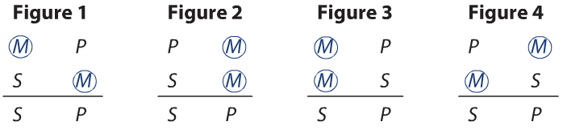

🔹 First Figure (SUB-PRE):
⤷ $M$ is the Subject of the major premise and the Predicate of the minor premise ($MP/SM/∴SP$).
🔹 Second Figure (PRE-PRE):
⤷ $M$ is the Predicate of the major premise and the Predicate of the minor premise ($PM/SM/∴SP$).
🔹 Third Figure (SUB-SUB):
⤷ $M$ is the Subject of the major premise and the Subject of the minor premise ($MP/MS/∴SP$).
🔹 Fourth Figure (PRE-SUB):
⤷ $M$ is the Predicate of the major premise and the Subject of the minor premise ($PM/MS/∴SP$).

🎼 Moods of Categorical Syllogisms
⤷ The Mood refers to the three-letter arrangement of the categorical proposition types ($A,E,I,O$) making up the Major Premise, Minor Premise, and Conclusion (e.g., $AAA,EAE,IAI$).
⤷ The 19 Valid Moods (Medieval Mnemonic Verses): Out of all possible combinations, only 19 moods follow the rules of correct deduction (VALID).
⤷ Intuition: Look at the three vowels inside each Latin code word—those three vowels tell you the exact valid mood for [Major Premise] [Minor Premise] [Conclusion] in that figure!

1st Figure (SUB-PRE):
BARBARA, CELARENT, DARII, FERIO.

2nd Figure (PRE-PRE):
CESARE, CAMESTRES, FESTINO, BAROCO

3rd Figure (SUB-SUB):
DARAPTI, FELAPTON, DISAMIS, DATISI, BOCARDO, FERISON

4th Figure (PRE-SUB):
BRAMANTIP, CAMENES, DIMARIS, FESAPO, FRESISON

⚖️ The Eight Canonical Rules & Their Corresponding Fallacies
The eight classical canons of categorical logic are divided into two operational halves: Rules 1–4 (governing terms and distribution) and Rules 5–8 (governing propositional quality and quantity).

🧩 Rules Governing Terms (Rules 1 to 4)

🔹 Rule 1: The Middle Term Must Always Be Taken in the Same Sense
Formal Requirement: The middle term must maintain an identical definition, nuance, and semantic reference across both premises.
⤷ Intuition: A logical bridge cannot connect two banks if it shifts location midway through. Shifting definitions covertly introduces a fourth term.
⤷ Associated Error: Fallacy of Equivocation (or the Fallacy of Four Terms / Quaternio Terminorum).
→ Concrete Example:
  - Major Premise: "Some handheld devices are mice."
  - Minor Premise: "A rodent is a mouse."
  - Conclusion: "∴ A handheld device is a rodent."
Defect: "Mouse" designates a computer hardware peripheral in the major premise, but a biological rodent in the minor premise. The syllogism lacks a unified middle term.

🔹 Rule 2: Terms in the Conclusion Cannot Have a Greater Extension Than in the Premises
Formal Requirement: If a term ($S$ or $P$) is particular (undistributed) within the premises, it cannot emerge as universal (distributed) within the conclusion.
⤷ Intuition: You cannot know something about all members of a class if your initial evidence only surveyed some of them. The effect cannot exceed the scope of its cause.
⤷ Associated Errors:
  - Fallacy of Illicit Major: The major term $P$ is universal in the conclusion, but was only particular ($p$) in the major premise.
  - Fallacy of Illicit Minor: The minor term $S$ is universal in the conclusion, but was only particular ($s$) in the minor premise.
→ Worked Translation & Example (Illicit Major):
  - Premise 1 (A): "All hammers are tools." $→$ $M+p$
  - Premise 2 (E): "No chisels are hammers." $→$ $S-M$
  - Conclusion (E): "∴ No chisels are tools." $→$ $S-P$
Symbolic Trace: $P$ in premise 1 is particular ($p$, predicate of affirmative A). In the conclusion, $P$ is universal ($P$, predicate of negative E). Since $p→P$, the argument commits the Fallacy of Illicit Major.

🔹 Rule 3: The Middle Term Must Not Occur in the Conclusion
Formal Requirement: The middle term ($M$) exists solely to establish an inferential link between $S$ and $P$; its purpose ceases once the conclusion is reached.
⤷ Intuition: The middleman introduces two parties and then steps away. If the middleman stays, no unmediated relationship between $S$ and $P$ has been formed.
⤷ Associated Error: Fallacy of Misplaced Middle Term.
→ Worked Translation & Example:
  - Premise 1 (A): "A steward is a flight attendant." $→$ $M+p$
  - Premise 2 (A): "A steward is a male." $→$ $M+s$
  - Conclusion: "∴ A steward is a male flight attendant." $→$ $M+sp$
Defect: $M$ ("steward") appears directly in the conclusion, rendering the syllogism formally invalid.

🔹 Rule 4: The Middle Term Must Be Distributed Universally at Least Once in the Premises
Formal Requirement: The middle term must appear as a capital letter ($M$) in either the major or minor premise.
⤷ Intuition: If both premises only address a partial portion of the middle term ($m$), the two premises could refer to entirely separate halves of that class, never overlapping.
⤷ Associated Error: Fallacy of Undistributed Middle Term.
→ Worked Translation & Example (Figure 2):
  - Premise 1 (A): "All stewardesses are females." $→$ $P+m$
  - Premise 2 (A): "All mothers are females." $→$ $S+m$
  - Conclusion (A): "∴ All mothers are stewardesses." $→$ $S+p$
Symbolic Trace: "Females" is the predicate of two affirmative propositions; hence both occurrences are particular ($m$). Because the middle term is never distributed, the syllogism commits the Fallacy of the Undistributed Middle.

📜 Rules Governing Propositions (Rules 5 to 8)

🔹 Rule 5: Two Affirmative Premises Cannot Yield a Negative Conclusion
Formal Requirement: If both premises are affirmative ($+$ and $+$), the conclusion must be affirmative ($+$).
⤷ Intuition: Affirming that $S$ relates to $M$, and $M$ relates to $P$, cannot logically justify tearing $S$ and $P$ apart. Separation cannot be derived from pure inclusion.
⤷ Associated Error: Fallacy of a Negative Conclusion Drawn from Affirmative Premises.
→ Worked Translation & Example:
  - Premise 1 (A): "All stones are hard." ($+$)
  - Premise 2 (I): "Some diamonds are stones." ($+$)
  - Conclusion (O): "∴ Some diamonds are not hard." ($-$)
Defect: Drawing a negative ($-$) conclusion out of two positive ($+$) premises violates Rule 5.

🔹 Rule 6: From Two Negative Premises, Nothing Follows
Formal Requirement: A valid syllogism cannot have two negative premises ($-$). At least one premise must be affirmative.
⤷ Intuition: Stating that $S$ is disconnected from $M$, and $P$ is disconnected from $M$, isolates all three terms. No common baseline exists to determine if $S$ and $P$ relate or not.
⤷ Associated Error: Fallacy of Exclusive / Negative Premises.
→ Worked Translation & Example:
  - Premise 1 (E): "A chair is not a table." ($-$)
  - Premise 2 (E): "A table is not a pen." ($-$)
  - Conclusion (E): "∴ A pen is not a chair." ($-$)
Defect: Both premises are negative ($-$), completely severing any valid deductive inference.

🔹 Rule 7: From Two Particular Premises, Nothing Follows
Formal Requirement: At least one premise must be universal (A or E). If both premises are particular (I or O), no valid conclusion can be drawn.
⤷ Intuition:
  - If both are particular affirmative (I and I), all terms are particular ($s,p,m$), violating Rule 4 (middle term never distributed).
  - If both are particular negative (O and O), it violates Rule 6 (two negative premises).
  - If one is I and one is O, there is only one distributed term across both premises (the predicate of O). But Rule 8 forces a negative conclusion, which distributes its predicate $P$. To distribute $P$ in the conclusion, $P$ must be distributed in the premise (Rule 2). That leaves zero distributed terms for $M$, inevitably violating Rule 4.
⤷ Associated Error: Fallacy of Two Particular Premises.
→ Worked Translation & Example:
  - Premise 1 (I): "Some cats are pets." $→$ $m+p$
  - Premise 2 (O): "Some pythons are not cats." $→$ $s-M$
  - Conclusion (O): "∴ Some pythons are not pets." $→$ $s-P$
Defect: Deriving a conclusion from two particular premises (I and O) invalidates the syllogism, triggering the Fallacy of Two Particular Premises and Illicit Major ($p→P$).

🔹 Rule 8: The Conclusion Follows the Weaker Premise
Formal Requirement:
- In Quality: Negative ($-$) is weaker than Affirmative ($+$). If one premise is negative, the conclusion must be negative.
- In Quantity: Particular ($s,p$) is weaker than Universal ($S,P$). If one premise is particular, the conclusion must be particular.
Intuition: An argument cannot emerge stronger or broader than the weakest link in its underlying evidence.
⤷ Associated Error: Fallacy of the Universal Conclusion Drawn from a Particular Premise.
→ Worked Translation & Example:
  - Premise 1 (A): "All mongoloids are mentally retarded." $→$ $M+p$
  - Premise 2 (I): "Some mongoloids are special children." $→$ $m+s$
  - Invalid Conclusion (A): "∴ All special children are mentally retarded." $→$ $S+p$
Defect: Premise 2 is particular, yet the conclusion was asserted universally ($S$), violating Rule 8 and Rule 2 (Illicit Minor, $s→S$).
  - Valid Conclusion: "Some special children are mentally retarded" ($s+p$, Mood AAI-3 / Datisi).

